Traffic Anomaly Detection Wireshark Whitebox

Step 1: Open the Kali Machine (IP: 172.16.14.51) in EVE to act as the attacker

Step 2: Open Windows1 (IP: 172.16.14.50) System in EVE to act as the targeted

Step 3: On windows1, launch Wireshark scan

Step 4: On Kali, launch the following: “sudo nmap -v -sV -O 72.16.14.50” to discover the following information
- The host
- Open ports: 135/139/445/3389/5357
-OS devices: Microsoft 10 1507-1607
-Mac Address: 50:01:00:02:00:00
- Services: mrpc; netbios-ssn; microsoft-ds; ms-wbt-server; http
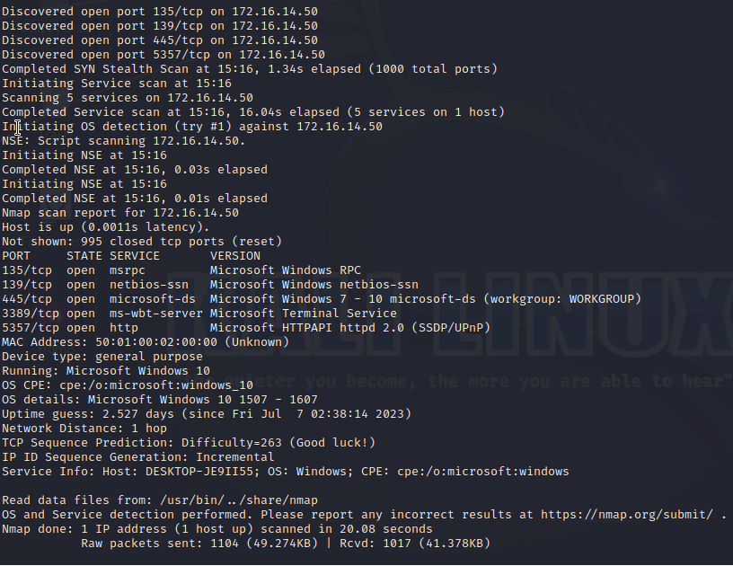
Figure 1: sudo nmap -v -sV -O 172.16.14.50

Step 5: Use the ARP filter on Wireshark to look into any Nmap scan that may have occurred on the Windows1 device
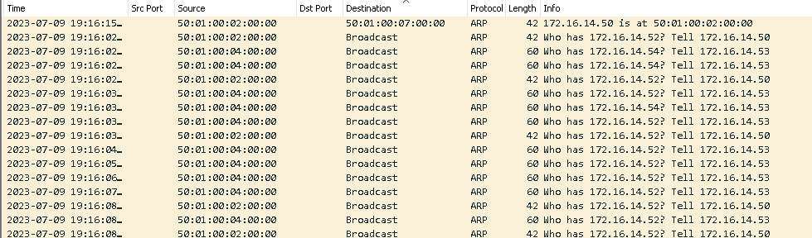

We can see on the ARP scan that there as been an early successful identification of the Windows MAC address on the first line. In spite of finding the address, the source device kept asking the target. It implies that an Nmap has been used.

Step 6: Capturing all open ports by using the filter “tcp.== [corresponding open port]”

Open ports are: 135/139/445/3389/5357

Port 135
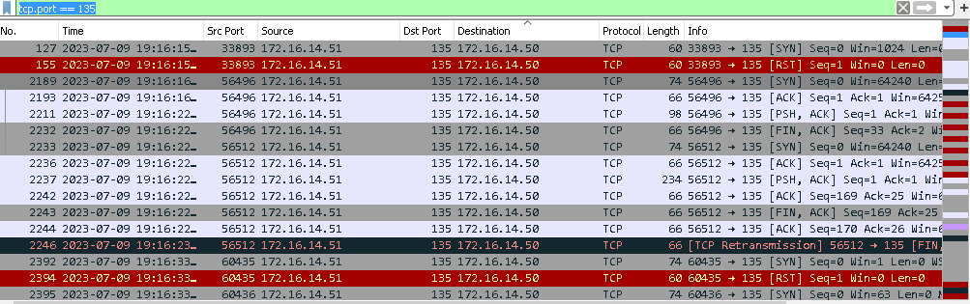

port 139

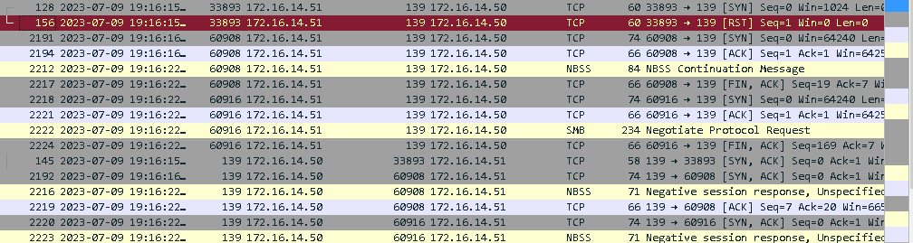

port 445

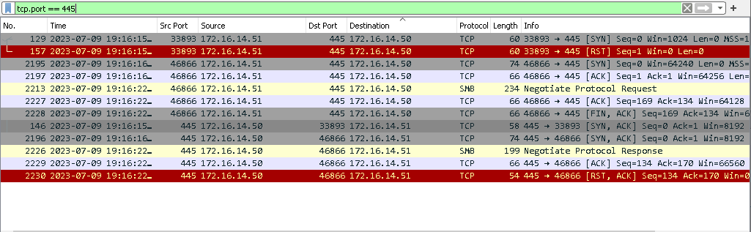

Port 3389

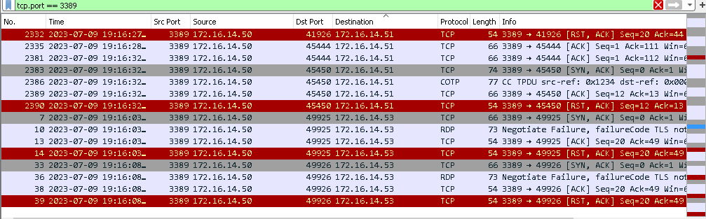
Port 5357

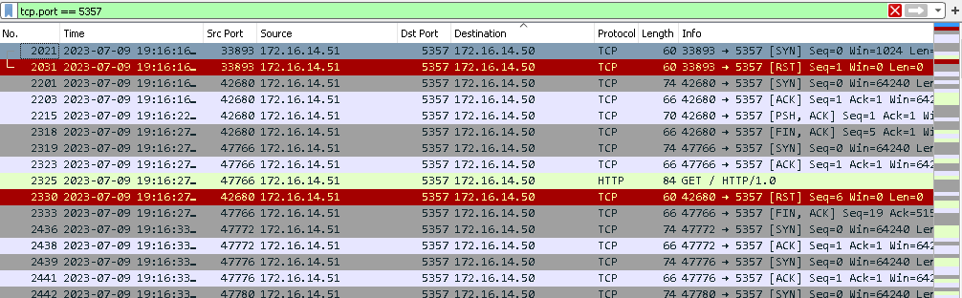

Step 7 Analyzing HTTP filter
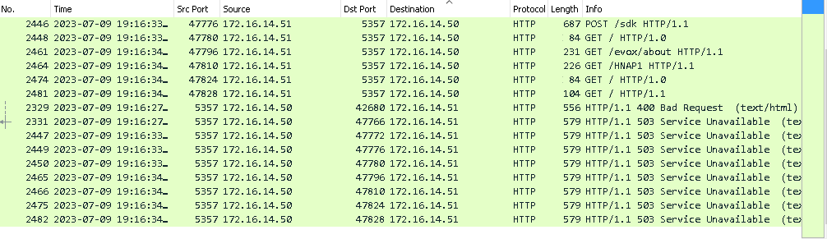

Need help to analyse

